Pavilion 3 Sportpark Pavillion3

3 Oakwood Drive

Loughborough

England

LE11 3QF

Tel: 01509 640298

Email: [westmidland@swimming.org](mailto:westmidland@swimming.org)

Website: [www.westmidlandswimming.org](http://www.westmidlandswimming.org)

25th April 2022

Dear colleague,

##### ANNUAL GENERAL MEETING

Notice is hereby given that the Annual General Meeting of the Swim England West Midland Region will be held ***at 09.00am on Saturday 14th May 2022,*** where the presence of your delegate(s) is required.

The meeting will be held via Zoom and the link will be circulated to those who return the appropriate delegate authorisation form.

The documents enclosed with this notice are as follows:

* Agenda
* Minutes of the Annual General Meeting of 24th April 2021
* Report & Accounts 1st January 2021 – 31st December 2021 (will be available online via website prior to AGM)
* List of Elections and Regional Appointments
* Delegate authorisation form(s)

Admission of members:

(a)   One person nominated by each club that is affiliated to the Company.

(b)   Two persons appointed by each County Association that is recognised by the Company.

(c)   One person nominated by each body that is affiliated to the Company that is not a county or club.

A member who is a nominee of an affiliated club must be a member of the club that he or she represents. Affiliated clubs shall advise the Company in writing of the identity of their nominee, and of any change in appointment.

Each nominee should complete, in full, a delegate authorisation form and return it to the Regional email, [westmidland@swimming.org](mailto:westmidland@swimming.org). Please note that an individual is entitled to one delegate card only, and cannot therefore represent more than one affiliated organisation, or attend the meeting in more than one capacity.

For those entitled to attend either as a member of the Management Board, as a Past President or Life Member of the Swim England West Midland Region or relevant ASA District, or those identified as standing committee secretaries, an individual form is attached to this email. In the case of error, please contact the Regional Office without delay.

A member of the Council or a club, body, association or organisation affiliated to the Region that wishes to question or have discussed any item in the Annual Report or the Financial Statements shall indicate his intention by giving notice to the Regional Office no later than seven days prior to the Annual General Meeting.

I look forward to welcoming you at the virtual meeting on 14th May 2022.

Yours sincerely,

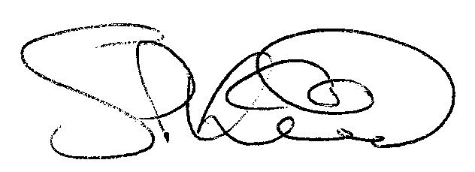

**Simon Kirkland**

## **Chair Swim England West Midland Region Ltd**